How to Enroll in Autobooks:
A Step-By-Step Guide

It's easy to get started with Autobooks!
Just follow the steps below to enroll in minutes and receive your first customer payment.
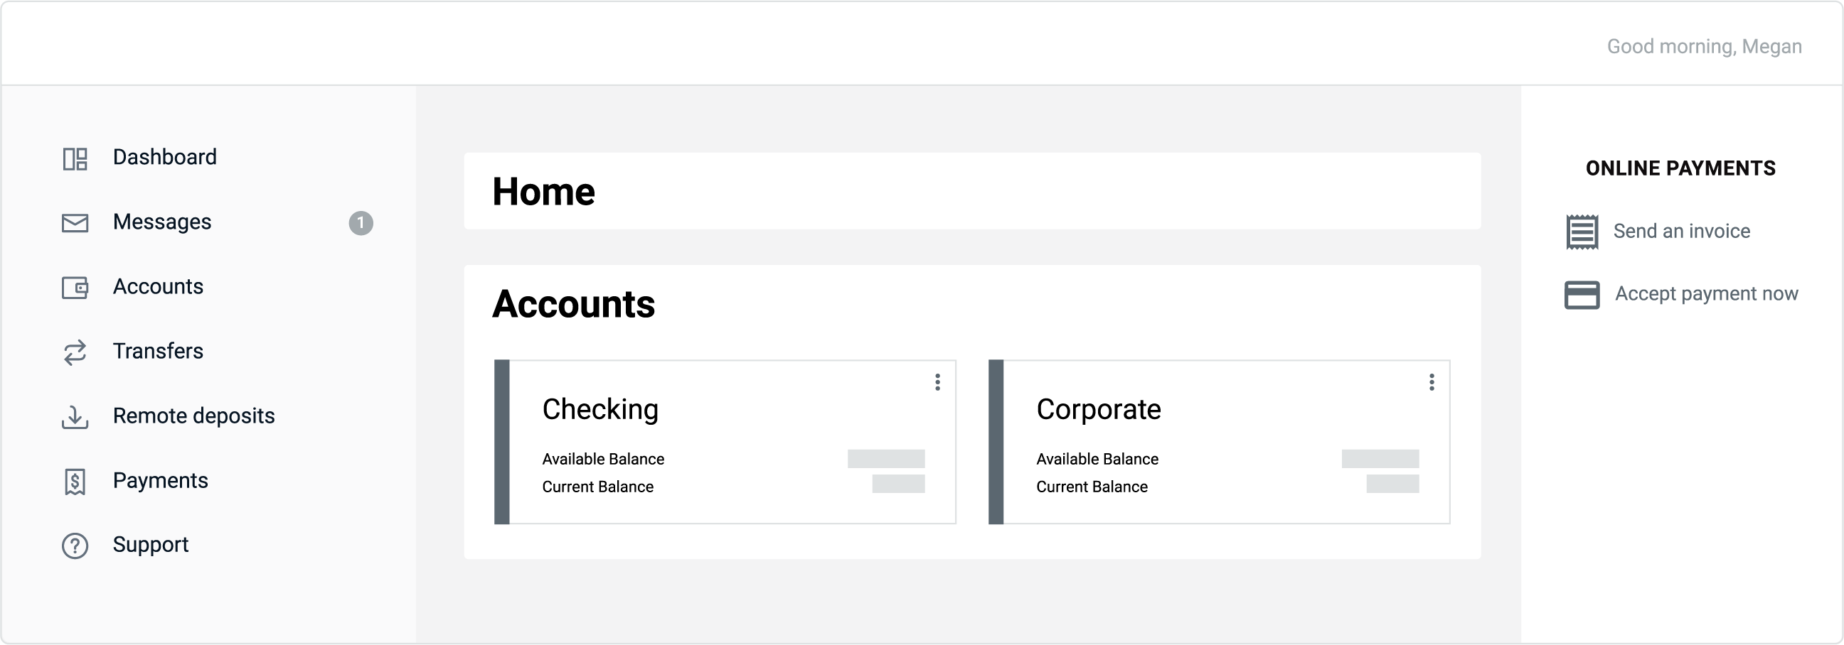
Step-by-step enrollment process
- Replace image (right click>change picture) with a screenshot of your digital banking dashboard.
- Change the color of the box to your branding and call out Autobooks.
- Replace the placeholder logo (right click>change picture) with your logo.

STEP 1
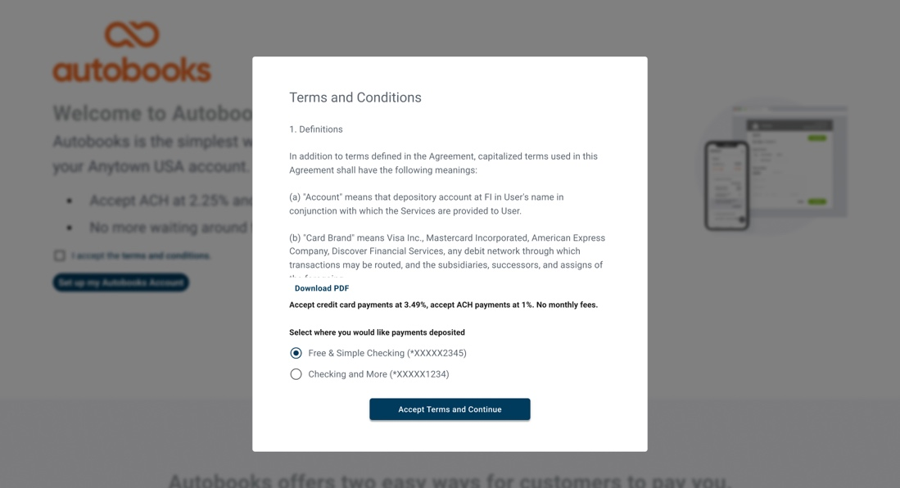
Click on Autobooks within online banking. The Terms and Conditions will display and allow you to select which checking account you wish to deposit funds (if you have more than one checking account).
STEP 2
You will be taken to a short tutorial. You can choose to create an invoice or access your payment link.
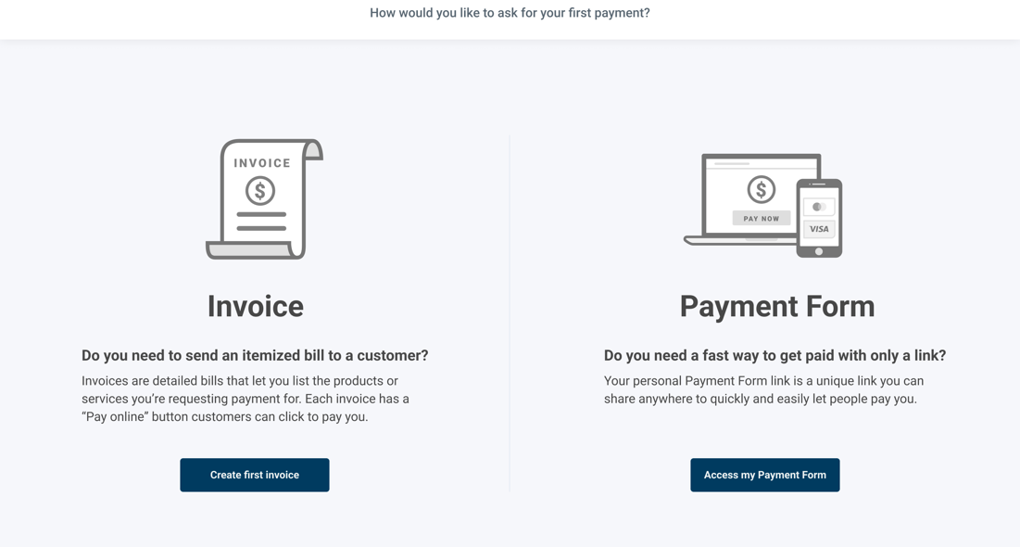

STEP 3
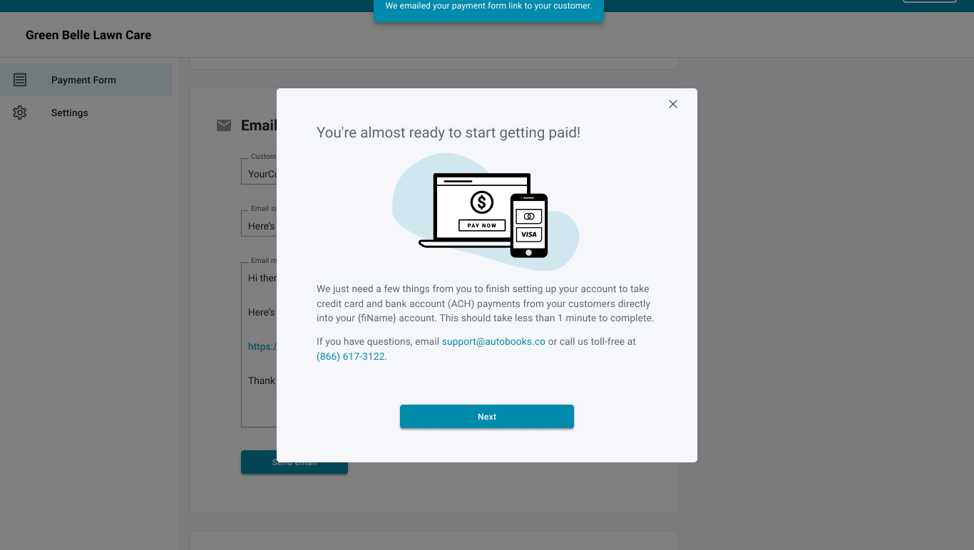
If Autobooks is missing key data for your business after you complete the tutorial, this information will be asked for now. Key data includes: The owner’s name, phone number, date of birth, SSN, or home address of the business and/or business owner.
STEP 4
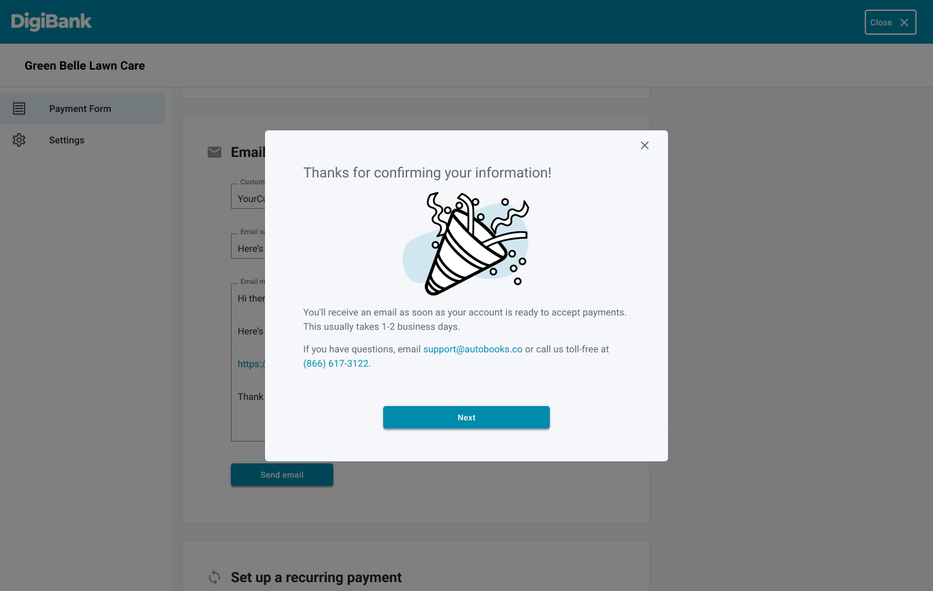
You will see a confirmation once the key data has been entered. You may click away from the key data gathering modal at any time before completion. If you do click away, there will be a persistent (clickable) reminder message that key data is required for payment processing approval. Your business cannot process your first payment without providing this information.

Once enrollment is complete, you can upgrade your Autobooks experience with additional features.

To add Accounting, Financial Reporting, and other features click the tab labeled “Accounting.” You will see monthly subscription and processing rate information. Click “Activate Autobooks” to complete your upgrade. Once activated, you will see the full Autobooks view.

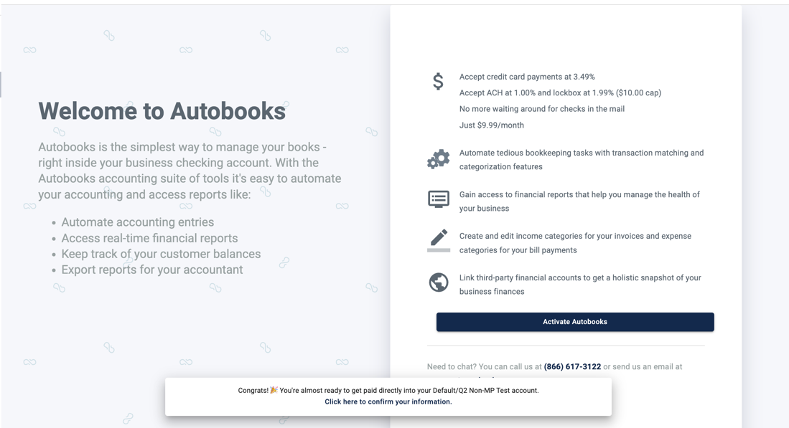

Upgrade Success Message
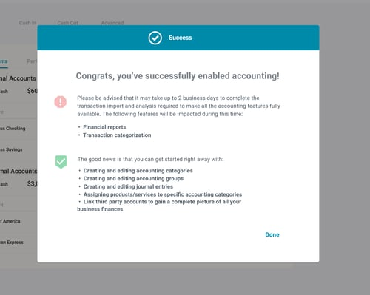

Fully Upgraded Autobooks view

